VIZ 1 Exercises 4
These exercises use the RevenueStreamGraphMusicIndustry project. If you don’t have it completed, use the uploaded version.

Exercise 4.1
Restructure your code as in the slide for today. You can use the following as inspiration.
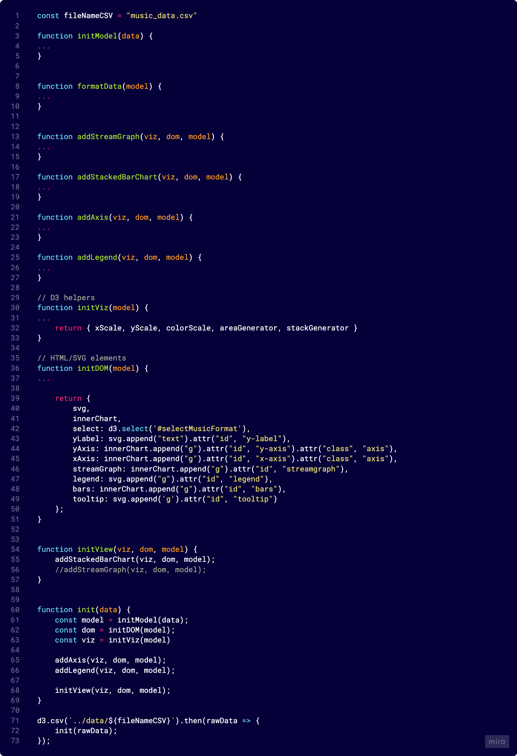

Exercise 4.2
Add event listener to your project. For now, let them write the event and data to the console. Test it and inspect the output.

Exercise 4.3
Add interaction to your project
- Add filtering
- Add a tooltip
You can use transitions as you please.

